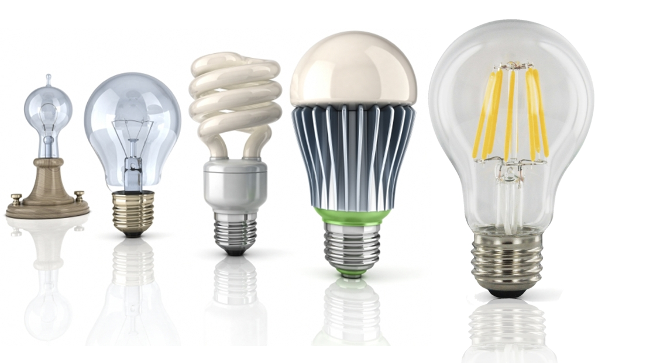
The dream of yesterday is the hope
of today and the reality of tomorrow.
Robert H. Goddard

3.1
Module 3 ELECTRICITY
Grammar: Perfect Tenses
Irregular plural forms
Word formation: suffixes -ment, -ion, -ence, -ice

Essential vocabulary
advance n completely adv discover v invent v reduce v turn v
advantage n current n effect v imagine v significant a velocity v
appear v develop v efficient n nuclear a since adv wave n
appliance n device n fuel n power n single a wireless a
charge n disappear v generate v property n solve v without prep

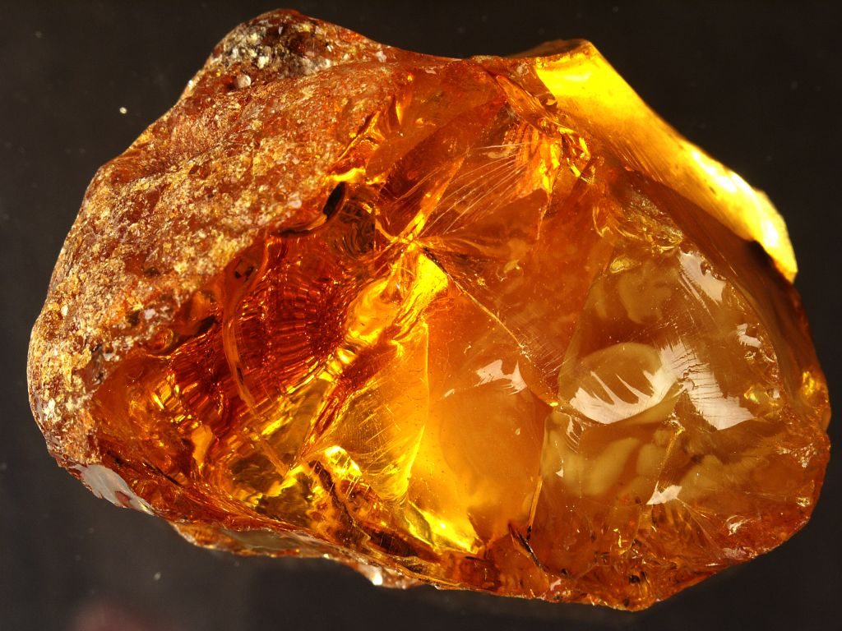
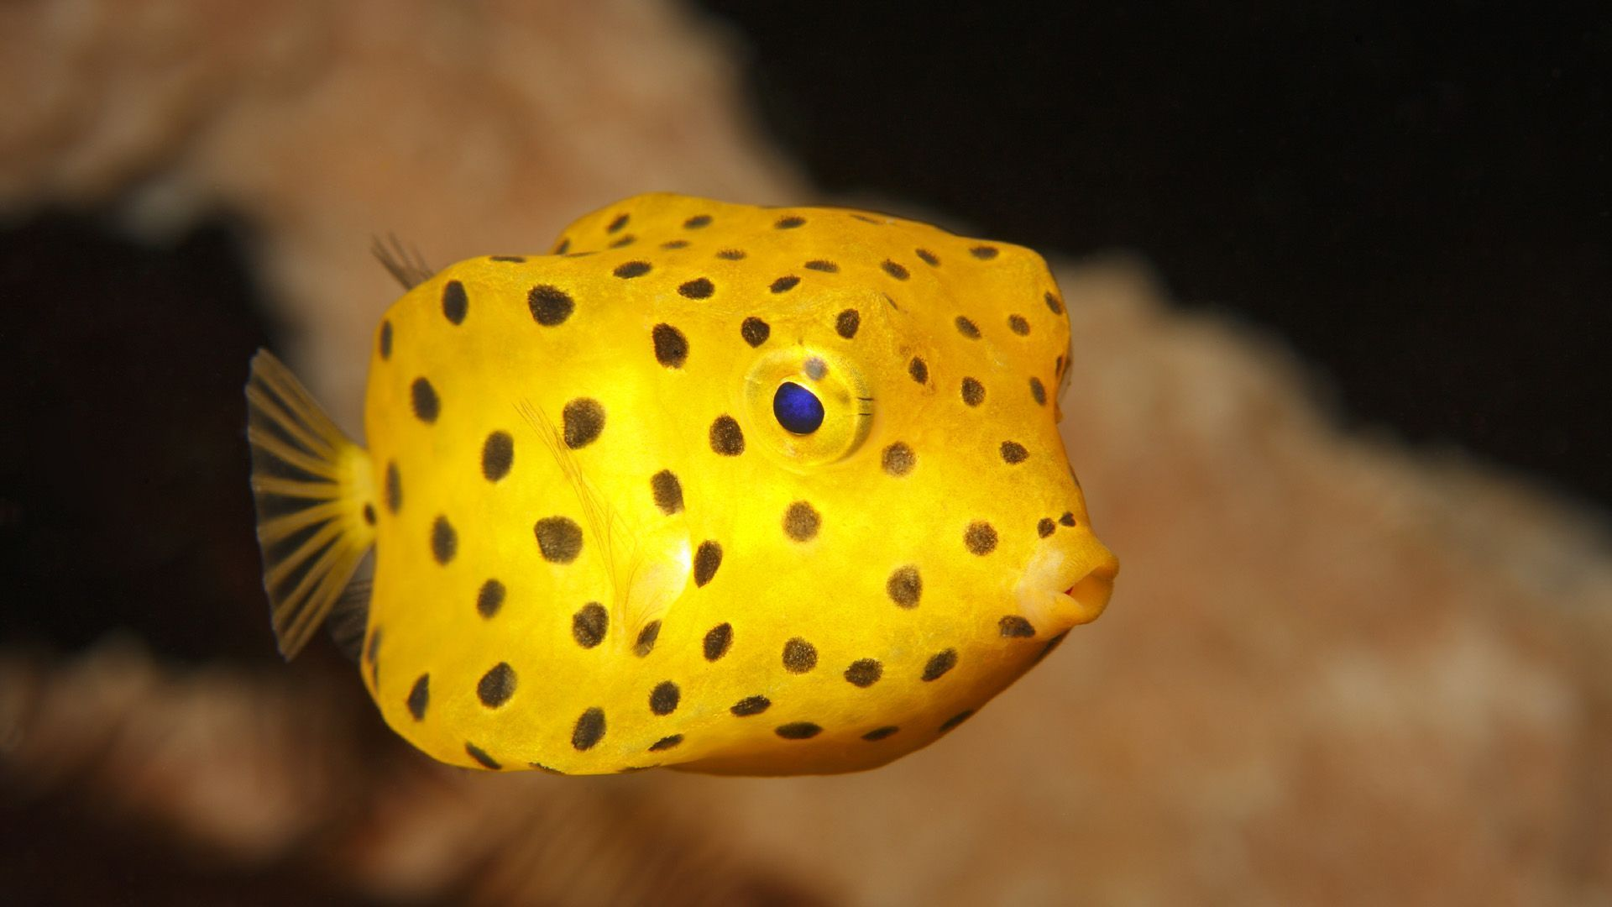

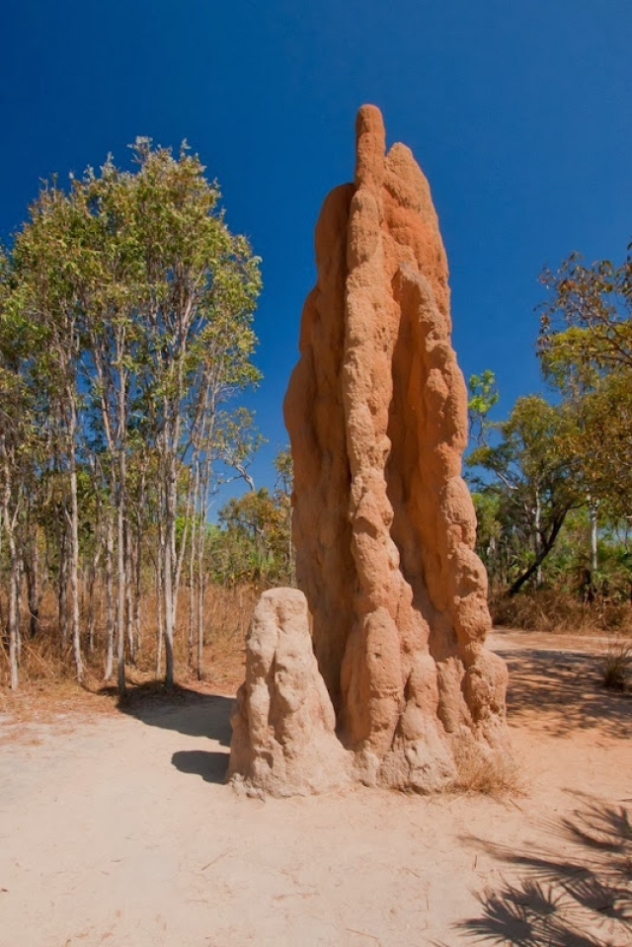
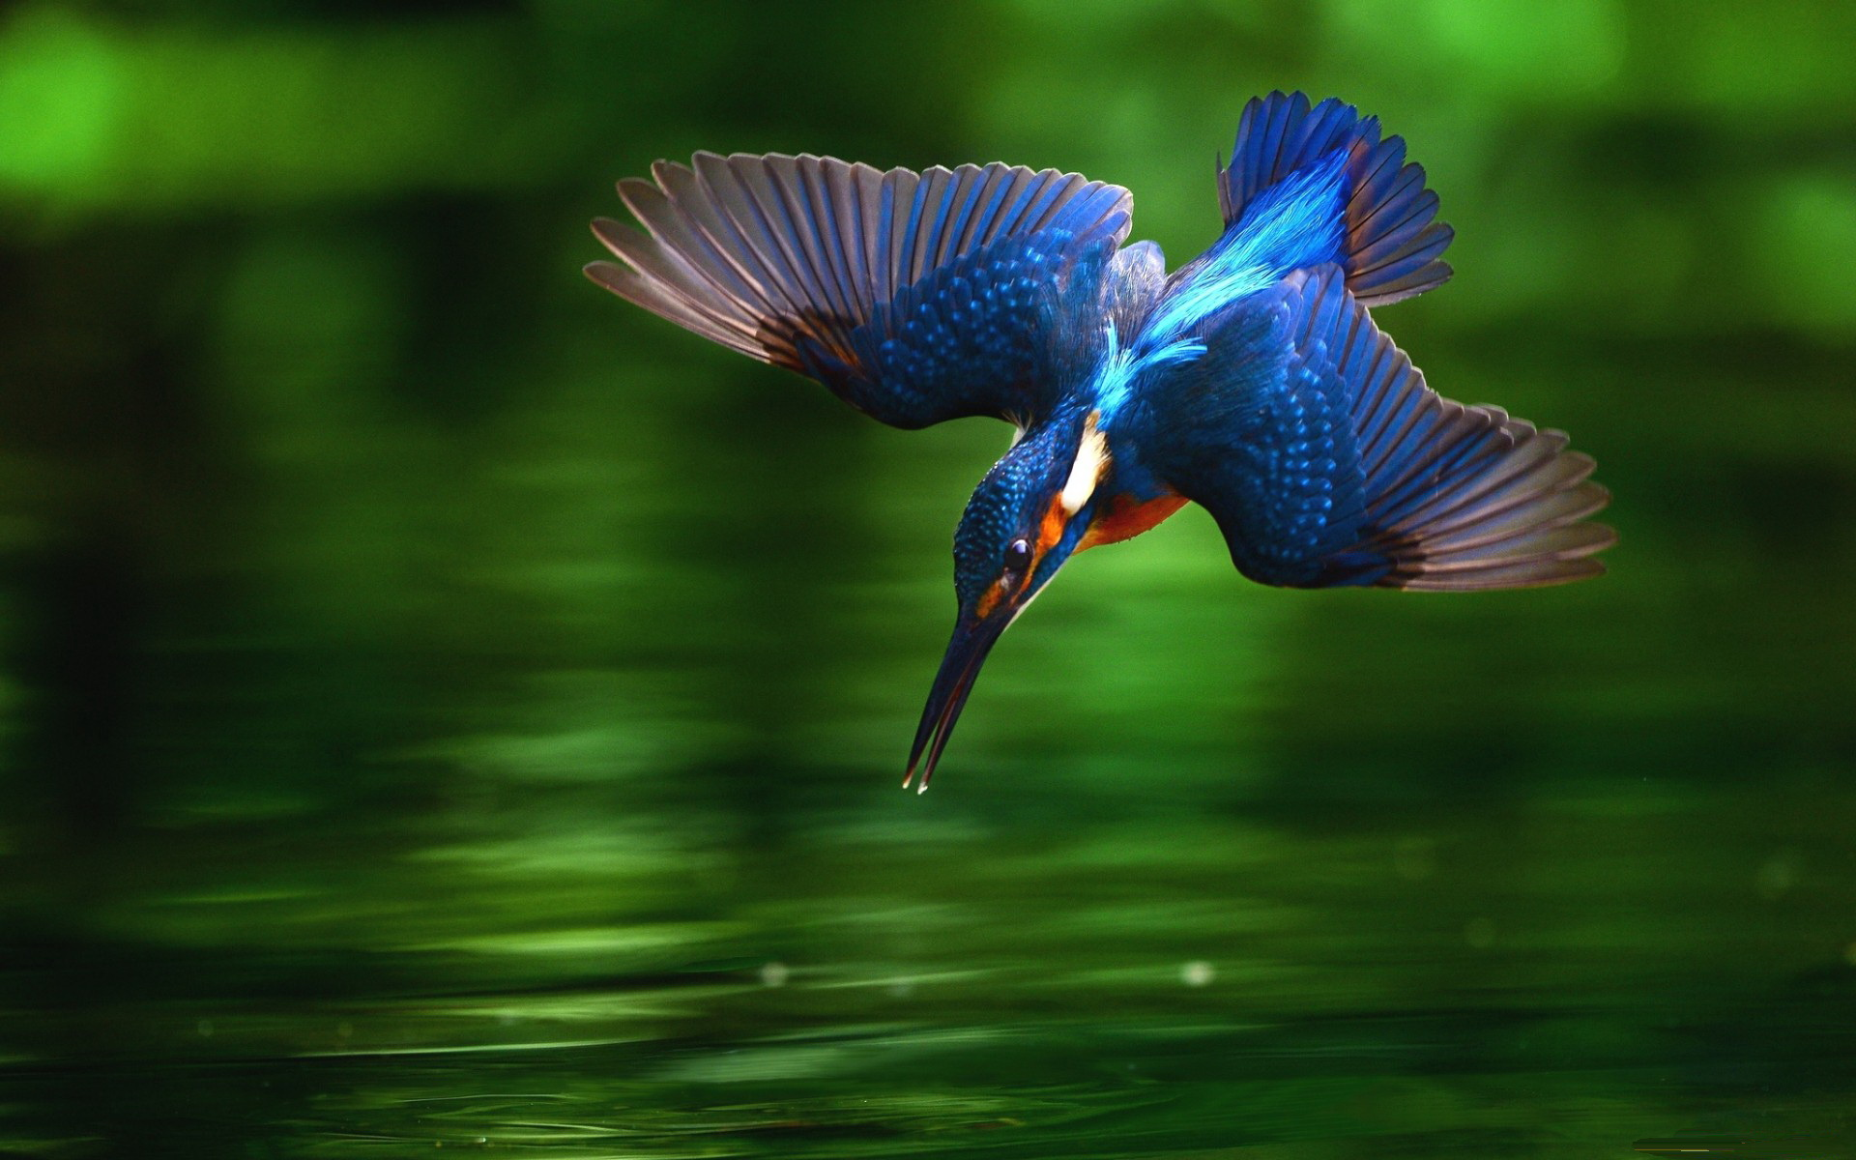
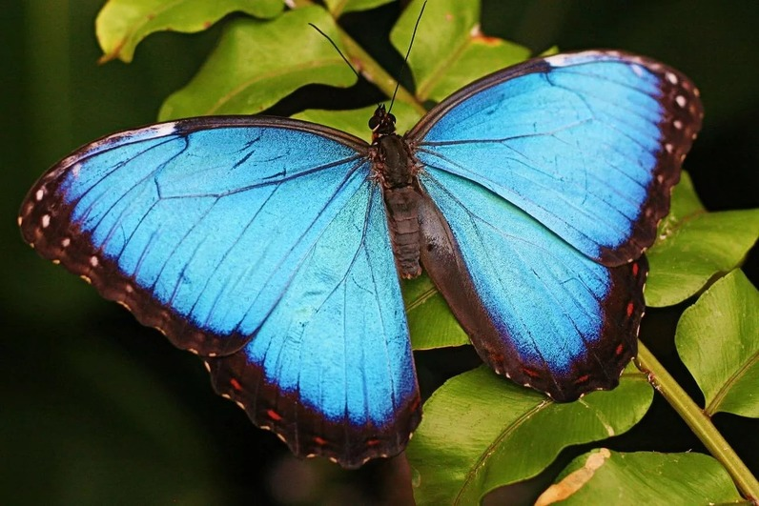
1 Look at the pictures and match them to the words in the box.
1_______________________ 2___________________________ 3_______________________
4________________________ 5___________________________ 6_______________________
d boxfish butterfly wings kingfisher amber termite mound plant leavesr/f
Find the spellings for these words.
[ˈkɪŋfɪʃə] [ˈæmbə(r)] [bʌtərflaɪ ˈwɪŋz] [ˈbɒksˌfɪʃ] [plɑːnt liːvz] [ˈtɜːrmaɪt maʊnd]

2 Which natural phenomenon on the list do you think inspired each of the following inventions?

1 butterfly wings a) displays for e-readers
2 boxfish b) super-aerodynamic car
3 amber c) solar cells that follow the sun
4 kingfisher d) air-conditioned building
5 plant leaves e) electricity
6 termite mound f) bullet train

* Search the Internet and answer these questions.
1 What is biomimicry?
2 What is bio-inspired engineering?
3 What is the main purpose of bionics?

The field of biomimicry - technology whose form and function takes its inspiration from nature -
is one of the fastest - growing in the tech innovation universe, expected to generate $1.6 trillion in
total output of GDP by 2030.
* GPD - Gross Domestic Product =ВВП

* Complete the sentences with the words from Exercise 2. Use them more than once.

boxfish termite mound amber plant leaves kingfisher (birds) butterfly wings

1 _____________are the ideal model for a lot of solar technology, so it only makes sense of manmade
solar panels would look to Mother Nature to improve the efficiency of their designs. Over time, solar
cells wear down – just like ___________ due to degradation caused by ultraviolet light. A team of
researchers revealed this week that they have created a new type of solar cell that can repair and reinvigorate itself by mimicking the functioning of organic vascular systems found in nature.

2 In 1996, Dieter Gurtler and his colleagues from the Mercedes Technology Center in Germany,
were looking for a model for a holistically conceived bionic car, respecting at once physics, design
and aerodynamics. The team’s first instincts were to use streamlined sharks, penguins, dolphins, and tunas. But on a visit to the Rosenstein Museum in Stuttgart, with its huge collection of preserved fish,
it became clear that their “ideas of tunas and sharks were not useful to design cars, which contain a cubicle for passengers, while swiftly-swimming fishes are compressed” It was their idea to choose a slowly but steadily swimming fish, and the _________ was the first option.

3 The “architecture “of ___________ creates a natural air-conditioning system that runs all by itself.
__________ are amazing little critters. They are tiny, even by insect standards, yet they build towers
as high as 7 meters to house colonies that can consist of several million animals.
But living in a fortress without windows has its downsides too. One challenge for the _______
is getting enough fresh air into the intricate system of tunnels they inhabit. There have been various
theories on how fresh air gets into the _______ but a news study published in this month’
Proceedings of the National Academy of Sciences has recorded what actually happens inside the ____
and revealed that the _______ ventilate themselves thanks solely to their ingenious design.

4 A bullet train emerging from a tunnel generates thunderclap due to the air pressure which builds up
in front of the nose. In the 1990s a Japanese engineer Eiji Nakatsu noticed that ____ __ could dive
into the water with barely a splash. His design for the Shinkansen bullet train, based on the ________ beak, not only reduced the noise of the train but was also more aerodynamic, using less power and enabling higher speeds.

5 The brilliant colour of some ______ _____ comes from an assembly of tiny plates in a specific
pattern that reflects light of a certain wave length. Researchers are looking to develop similar colour displays for e-readers; they would work by reflecting light, not transmitting it from behind the screen,
like LCD screens do.

6 The effects of static electricity were first recorded by a Greek philosopher Thales of Miletus
[ˈθeɪliːz əv maɪ'liːtəs] who lived between 624 and 546 BC. He is said to have experimented with ______which the Greeks referred to as elektron and cat fur to create an electrical discharge as well as magnetism.

3 Think of any of the everyday appliances. Most of them run on electric power.
We are using electricity literally every moment! If you look around at any time,
you will find at least one appliance that’s using electricity!

Which is the odd one out?

A an iron a computer a dishwasher a bicycle
B a coffee machine an elevator a zip a hairdryer
C a doorbell a stapler a microwave a video camera
D a marker a mixer a fax machine an air-conditioner
E a pencil sharpener a TV set a tram a hoover (vacuum cleaner)
F a shoe dryer a light bulb a ruler a washing machine

4 Work in pairs. Imagine that you are at home. What common electrical appliances do you
normally use? Ask and answer questions about your home appliances.

Example: Student A: Do you use an electric kettle at home?
Student B: Oh no! I think it’s an energy-consuming device and I’m money-conscious.
A: But an electric kettle is a time-saving device, isn’t it?
B: Yes, it is.
A: And, as you know, time is money.

Make use of the phrases below.
It’s a useless thing…, an innovative staff…, it’s a waste of money…, it’s time - (energy, money)
consuming, I’m environment - (fashion, comfort) conscious…, it is not reliable.

5 Match words 1-8 to definitions a)-h).

1 appear v a) the speed of something in a particular direction
2 charge n b) not having, experiencing or showing something
3 discover v c) the amount of electricity that is put into a battery or carried by a substance
4 since adv d) to be written or mentioned somewhere
5 significant a e) to produce or design something that has not existed before
6 velocity n f) from a time in the past until a later past time, or until now
7 without prep g) large or important enough to have an effect or to be noticed
8 invent v h) to find something that already exists or learn about it for the first time,
before anyone else does
6 Write the noun form of the verbs.

appear ___________ reduce ____________ turn _____________
imagine ___________ replace ____________ solve _____________
discover ___________ develop ____________ effect ____________
invent ___________ generate ____________ believe ____________

7 Choose the correct alternative.

1 We owe to a certain extent, our ‘electrical lives’ to those who invented/discovered electricity.
2 We can’t imagine living with/without electricity.
3 Lightning is simply an electrical charge/discharge.
4 The magnetic affect/effect of minerals like magnetite was known to the ancient Greeks.
5 James Maxwell discovered/developed the electromagnetic theory of light.

8 Read the article about the history of electricity. Which of the following facts are not mentioned?

a) origin of the word electricity b) electricity is a natural phenomenon c) attractive effect of amber
d) electrical shock as a cure e) Maxwell’s equations f) positive and negative charges

Useful notes:
catfish [ˈkætfɪʃ] - сом
feather [ˈfeðə] - перо
Thales of Miletus [ˈθeɪliːz əv maɪ'liːtəs] - Фалес Милетский, древнегреческий философ и математик
William Gilbert - Уильям Гильберт, английский физик и естествоиспытатель
lodestone [ˈləʊdstəʊn] - магнит
Pseudodoxia Epidemica (лат.) - сочинение Томаса Брауна «Ошибки и заблуждения»
Charles Coulomb - Шарль Огюстен де Кулон, французский военный инженер и учёный-физик
Luidgi Galvani -Луиджи Гальвани, итальянский врач, физиолог и физик
Alessandro Volta - Алессандро Вольта, итальянский физик, химик и физиолог
Georg Ohm - Георг Cимон Ом, немецкий физик
James Maxwell - Джеймс Максвелл, британский физик, математик и механик

Electricity is a force of nature and has been around us since the creation of universe.
Since ancient times, people have come across various instances of electricity being manifested in nature.
The earliest mention of electric phenomena is found in ancient Egyptian texts from about 2750 BC
(roughly 4750 years ago). These texts talk about electric fish that were known as ‘Thunders of the Nile’
and defenders of other fish. So the earliest discovery of electricity in recorded history was in the form of
bio-electricity!
The mention of this electric fish like catfish has been found in Greek, Roman and Arabic chronicles.
In fact in some instances, there is even a mention of electrical shocks from these fish being used as a cure
for headaches.
Many ancient civilizations have reported the attractive effect that amber has on light objects like feathers
when rubbed against cat fur. The magnetic effect of minerals like magnetite was known to the ancient
Greeks. Around 600 BC, a Greek philosopher Thales of Miletus, investigated the static electric effect of
amber and wrongly classified it as a magnetic effect arising out of friction. However, later in modern times,
electricity and magnetism were proved to be the two manifestations of a single force of electromagnetism.
After that, in 1600 AD, an Englishman named William Gilbert studied the phenomena of electricity and
magnetism and distinguished between the electric effect of amber and magnetic effect of lodestone.
He gave the name ‘electricus’ (Latin) to the phenomenon of attraction showed by amber. Not surprisingly,
it was derived from the ancient Greek word for amber, which was ‘elektron’. This gave rise to the modern
word of electricity which first appeared in print in the book Pseudodoxia Epidemica written by
Sir Thomas Brown in 1646.
In the 18th century, Benjamin Franklin used the Leyden jar to establish that lightning is simply an electrical
discharge, Charles Coulomb demonstrated that the force between charges is inversely related to the
square of the distance between the charges, Luigi Galvani performed experiments revealing that electricity
is present in every animal, and Alessandro Volta developed the forerunner of the electric battery.
Later, in the 19th century Pavel Yablochkov developed a system of electric illumination, based on single-phased
alternating current, Georg Ohm introduced an important relationship between potential, current, and
resistance which we now refer to as Ohm’s law, Michael Faraday demonstrated his theory of
electromagnetic induction, James Maxwell developed the electromagnetic theory of light, which among
other things , revealed that electromagnetic waves travel through air at the velocity of light.
By the end of the 1800s, a significant number of the fundamental equations, laws, and relationships
had been established, various fields of study, including electronics, power generation, and calculating
equipment, started to develop in earnest.
Thus we see that the history of electricity runs right from the period before Christ up to the computer age
today. We owe to a certain extent, our ‘electrical lives’ to those who discovered electricity.
Thanks to them, the lightning of the skies was put to good use on Earth, in the form of this brilliant energy
we can’t imagine living without – electricity.

9 Read the article again. Are the statements true (T), false (F) or is the information not given (NG)?

1 Electricity was invented by a Greek philosopher Thales of Miletus. T/F/NG
2 The phenomenon of static electricity has been toyed with since antiquity. T/F/NG
3 The Greeks called amber (used to demonstrate the effects of static electricity) elektron. T/F/NG
4 The word electricity first appeared in print in the 17th century. T/F/NG
5 Yablochkov’s light system exhibited in Paris in 1878 was popular all over the world. T/F/NG
6 Failures never discouraged Faraday. He felt failures also teach. T/F/NG
7 Maxwell revealed that electromagnetic waves travel through air at the velocity of light. T/F/NG
8 In 1895 Wilhelm Rontgen discovered electromagnetic waves of high frequency. T/F/NG

Did Edison invent the light bulb, Marconi the radio, Bell the telephone, Morse the telegraph?
The answers are “no”. They didn’t invent the wheel. They were instrumental in making it better
and in some cases, obtaining the patent.

10 Watch the video “The Discovery Of Electricity ” and you will discover it took several people,
along the way, to make the light bulb glow.

Useful notes:
Joseph Swan – a British physicist and chemist. He is most famous for his role in the development
of the first incandescent light bulb (лампа накаливания)
spark – искра, искровой разряд
kite – воздушный змей
pots with sheets of copper inside – сосуды с тонкими пластинами меди внутри
Persian – a person from ancient Persia, now called Iran

11 Work in pairs. Ask and answer the questions on the history of electricity.

Example: Student A: When did the word ‘electricity’ first appear in print?
Student B: Well, I think it was first used in the book “Pseudodoxia Epidemica” in 1646.

12 Watch the video “The Present Perfect Tense ”.
Then complete the sentences with the correct form of the present perfect or past simple.

1 Success of the Yablochkov candle in 1878 ________(exceed) all expectations – mass media
all around the world ____(write) about the outstanding invention of a Russian scientist.
2 Electricity ______(be) a subject of scientific interest since at least the seventeenth century.
3 In the 19th century the subject of electrical engineering with tools of modern research techniques,
__________(start) to intensify.
4 Electricity is used with telecommunications, and indeed the electrical telegraph, demonstrated
in 1837 by Cooke and Wheatstone _____(be) one of its earliest applications.
5 Electricity is the best source of energy. While there are other sources of energy none of them
__________(reach) the stage where they can be used to provide the power to help modern life go.
6 The processes used to produce electricity using the sun’s energy historically ________(be) more
expensive than using conventional fossil fuels.
7 In 2015, less than 1% of the nation’s electricity __________(supply) by solar power.
8 In 1827 Georg Simon Ohm _________ (quantify) the relation between electrical current and potential
difference between conductors – leading to Ohm’s law.

13 Choose the correct alternative.

1 For centuries natural scientists and engineers have inspired / have been inspired by life’s devices.
2 A number of design methods, intended especially to guide industrial designers in carrying out
the development of biologically inspired design, have been proposed / have proposed.
3 Taking a leaf out of nature’s book, scientists have developed / have been developed technologies that
seek to mimic some of life’s unique innovations.
4 Electrical phenomena have studied / have been studied / has been studied since antiquity, though
advances in the science were not made until the seventeenth and eighteenth centuries.
5 Electricity is an extremely flexible form of energy, and has adapted / has been adapted to a huge and
growing number of uses.
6 Optical fibre and satellite communication technology have taken / have been taken a share of the market
for communication systems, but electricity can be expected to remain as essential part of the process.
7 Volta discovered that chemical reactions could be used to create cathodes and anodes. The difference
of electric potentials between them could lead to the flow of a current between them. The unit of
potential difference has been named / has named as ‘volt’ in his honour.
8 Coulomb mathematically articulated the attraction between electrified bodies. This laid / was laid
the foundation of quantitative study of electricity.
14 Look at the examples and complete the rules. Write for or since.

I haven’t seen you since we left university.
I haven’t seen you for ages.
Rules
1 We use __________ to say when an activity started.
2 We use __________ to say how long an activity has continued.
3 We use _____ with a period of time and ______ with a point in time.

Complete these sentences with for or since.

1 I’ve been a student… two years.
2 We haven’t had any rain … a very long time.
3 That building’s been there …the 19th century.
4 We’ve only been here …two minutes.
5 I haven’t seen you … the last conference.
6 I’ve worked for the same company … 2012.
7 We’ve been very successful …we operated a store in China.
8 He’s been the team leader… ten months.

15 Work in pairs or groups. Find out if your partner(s) have ever done the things on your list.
Use the past simple when you start talking about the definite time.

Example: A: Have you ever been to China?
B: No, I haven’t. What about you?
A: Oh, I’ve been twice.
B: Where did you go exactly?
A: I went to Beijing and Shanghai.

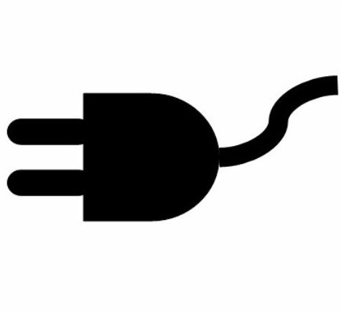
Electricity is the source of power for all life

3.2
16 Who are the scientists that gave their names to electrical units? Who are all these people
that we name theorems after in the lectures? Look at the photos and match the names to the photos.

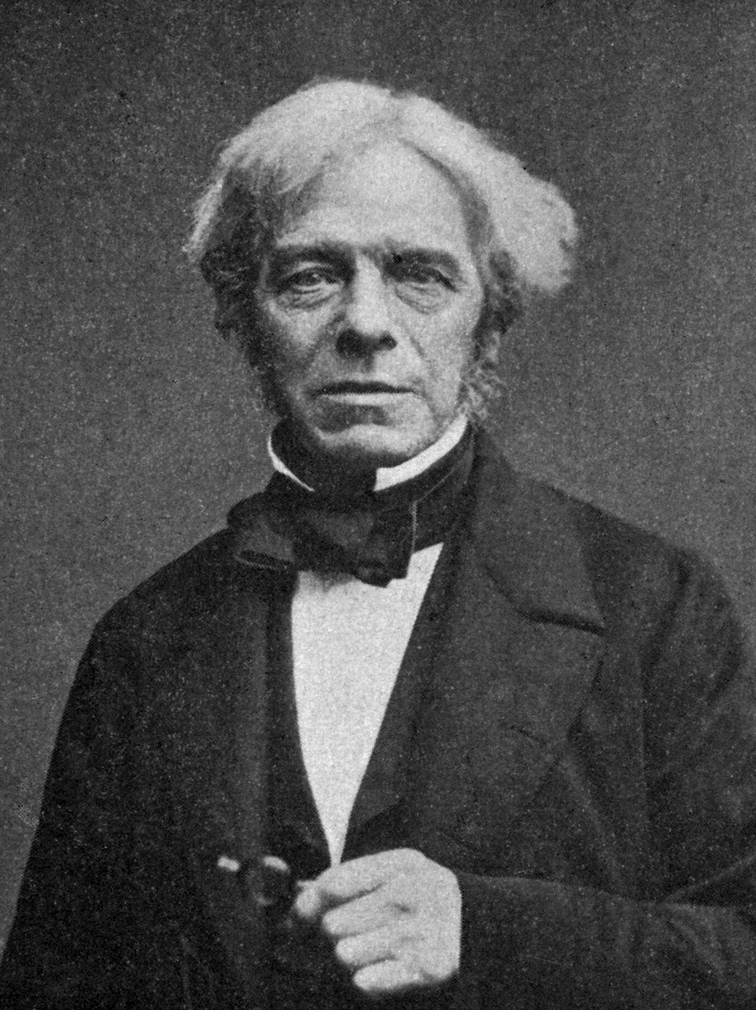
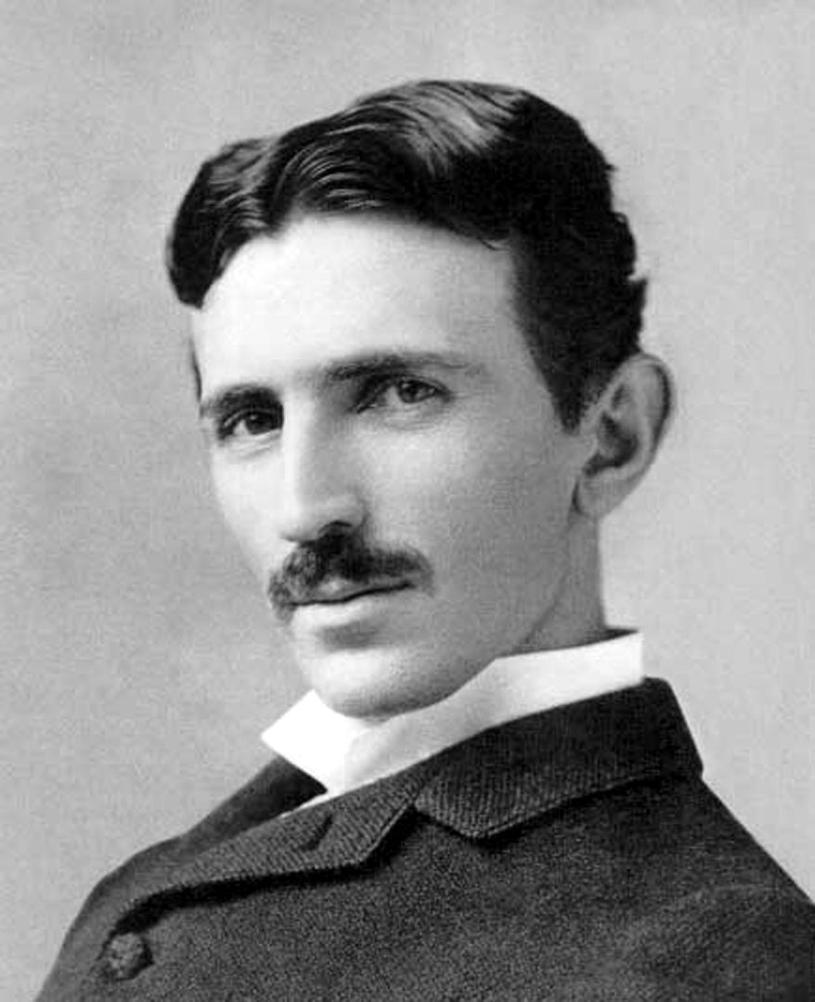
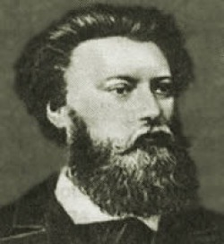

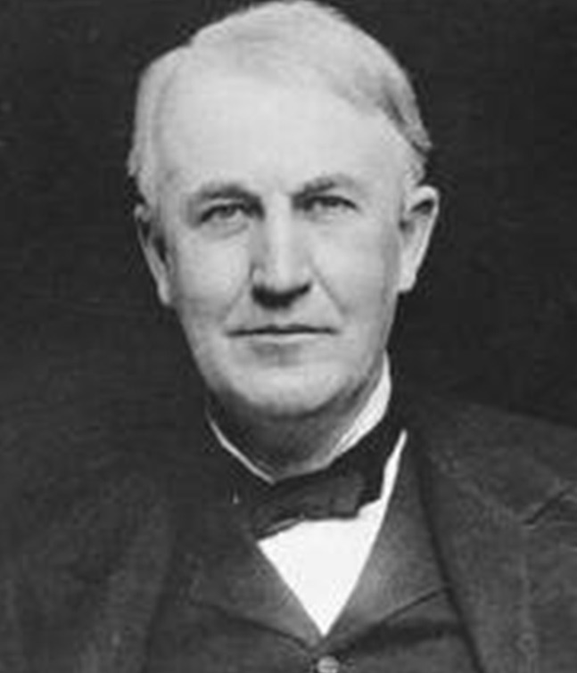
1_______________ 2________________ 3________________

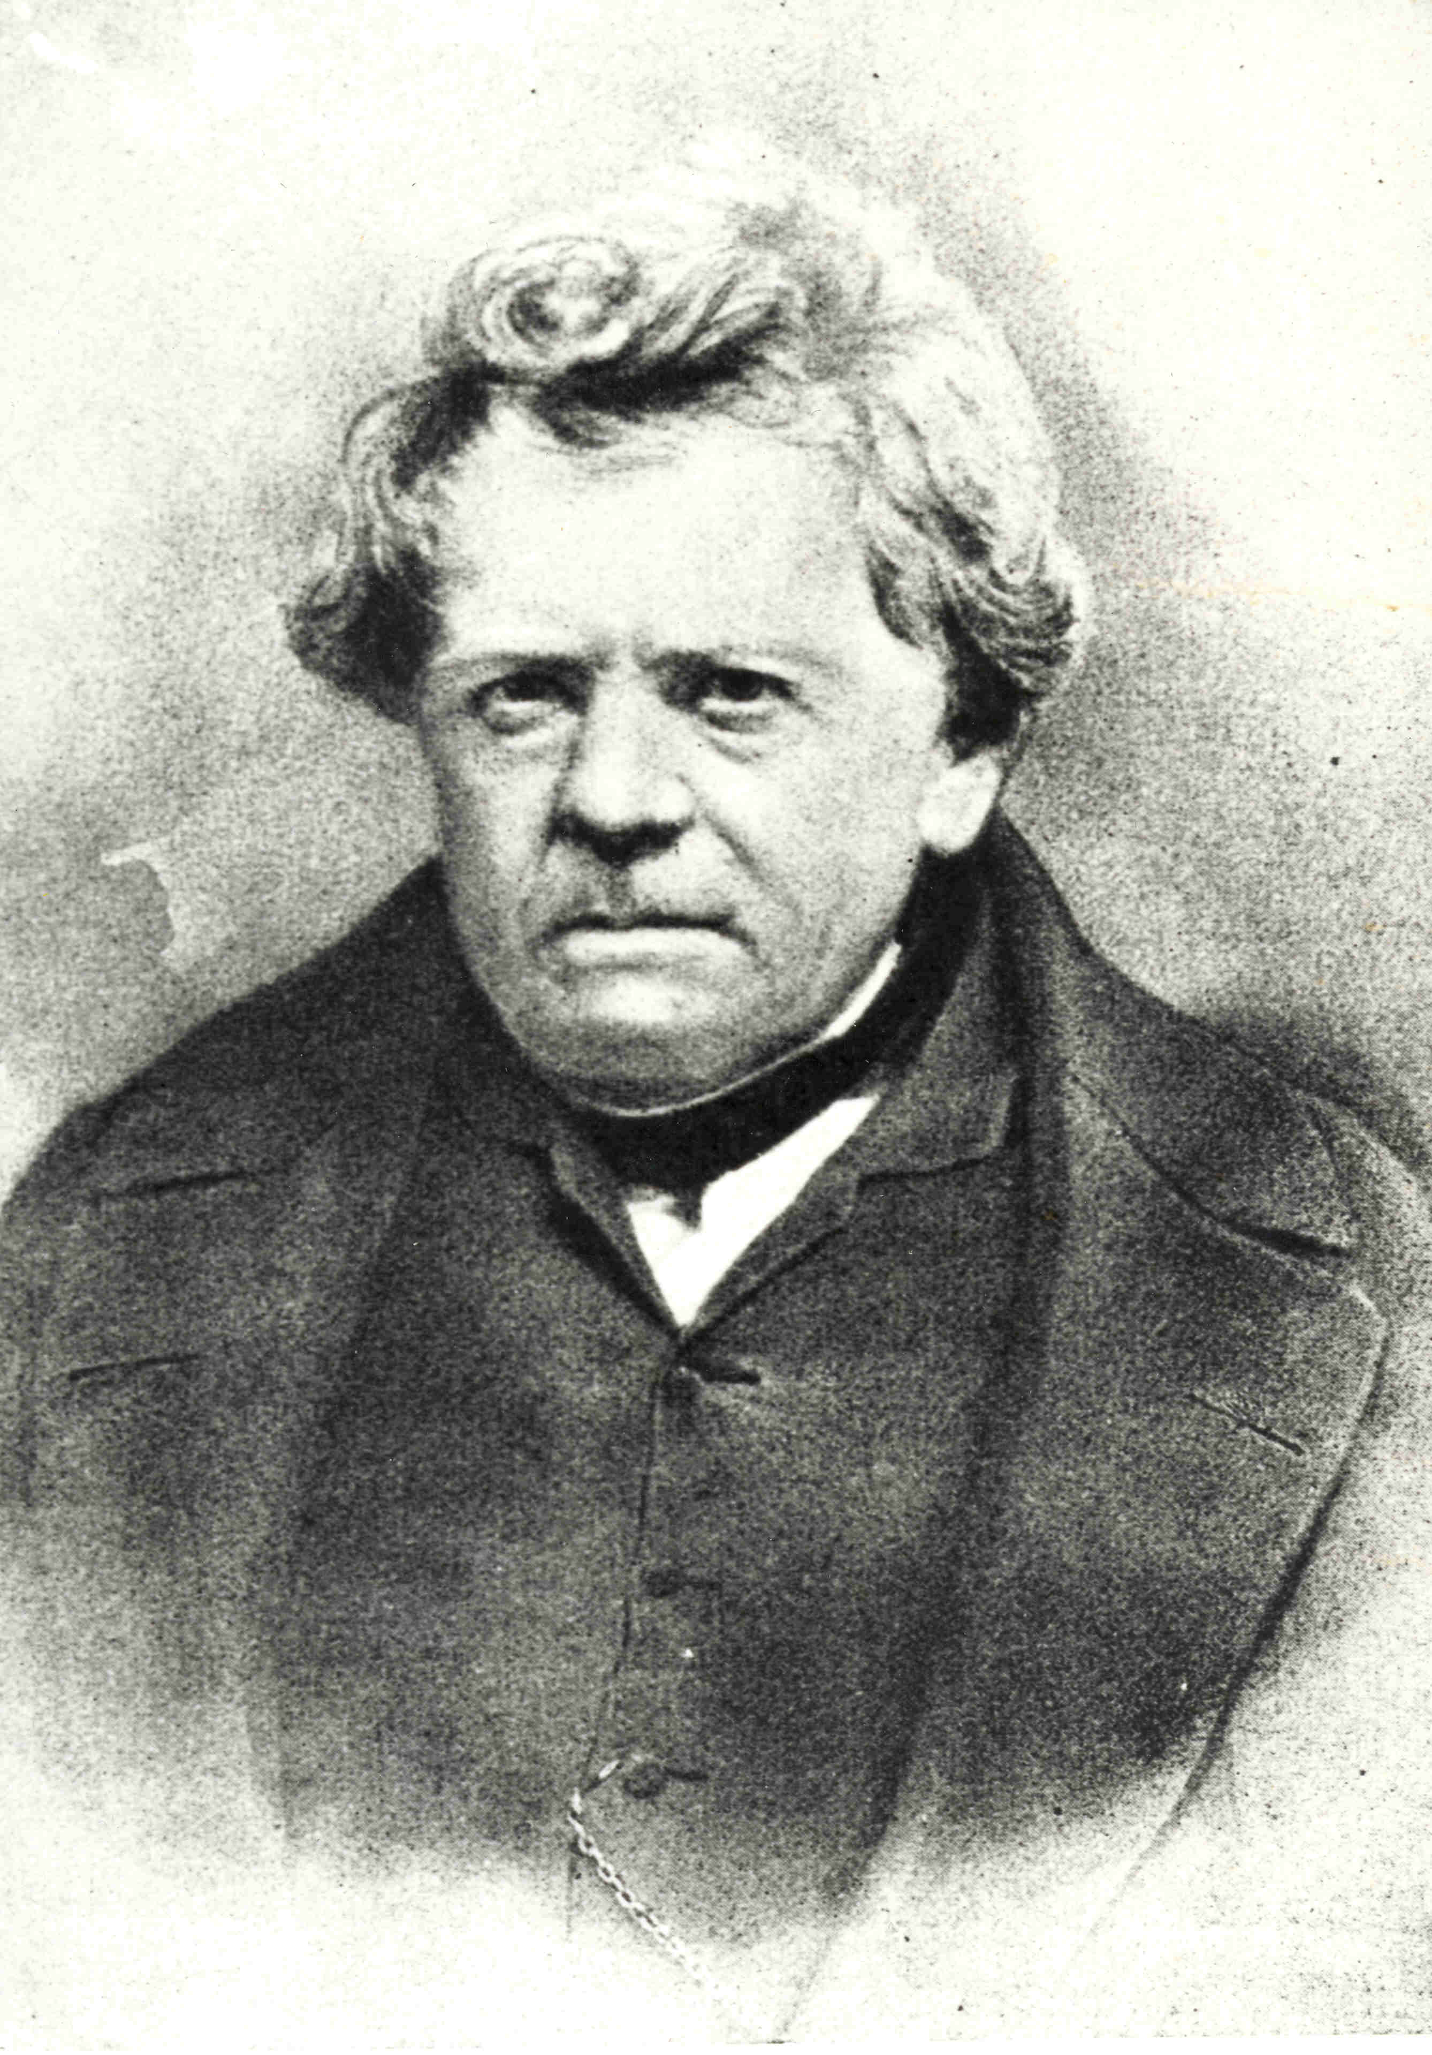
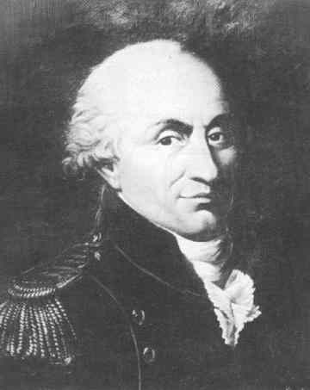

4_________________ 5__________________ 6________________

Georg Simon Ohm Pavel Yablochkov Charles Augustin de Coulomb
Nikola Tesla Michael Faraday Thomas Edison
Alessandro Volta Andre Marie Ampere Luigi Galvani

17A Complete the sentences.

Farad, the unit of capacitance is named after…
Ampere, the unit of measurement applied to the flow of charge through a conductor is named after…
Ohm, the unit of measurement applied to resistance is named after…
Coulomb, the fundamental SI* unit of measure for charge is named after…
Tesla, the SI* unit of measurement of the strength of magnetic field is named after…

*SI The International System of Units

B Choose one scientist you like most and prepare a short talk on his or her life and inventions.
Search the Internet if necessary.

18 Read the article about the famous inventor Nikola Tesla.
Choose the most suitable heading for each of the numbered sections from the list A-D.

A The Fall from Grace B Famed Inventor C Early Life D Legacy E Synopsis
1 _______________________
Inventor Nikola Tesla was born in July of 1856, in what is now *Croatia. He came to the United
States in 1884 and briefly worked with Thomas Edison. He sold several patent rights, including
those to his alternating-current machinery, to George Westinghouse. His 1891 invention, the
“Tesla coil”, is still used in radio technology today. Tesla died in New York City on January 7, 1943.
2________________________
Nikola Tesla was born on July 10, 1856, in what is now Croatia. Tesla’s interest in electrical
invention was spurred by his mother, who invented small household appliances in her
spare time while her son was growing up. Tesla’s father was a priest and a writer, and
he pushed for his son to join the priesthood. But Nikola’s interests lay squarely in the sciences.
After studying at the Realschule, Karlstadt; the Polytechnic Institute in *Graz, *Austria; and the
University of *Prague during the 1870s, Tesla moved to *Budapest, where for a time he worked at
the Central Telephone Exchange. It was while in Budapest that the idea for the induction motor
first came to Tesla, but after several years of trying to gain interest in his invention, at age 28 Tesla
decided to leave Europe for America.
3 __________________________
In 1884 Tesla arrived in the United States with little more than the clothes on his back and a letter
of introduction to Thomas Edison, whose DC-based electrical works were fast becoming the standard
in the country. Edison hired Tesla, and the two men were soon working tirelessly alongside each
other, making improvements to Edison’s inventions. However, several months later, the two parted
ways due to a conflicting business-scientific relationship, attributed by historians to their incredibly
different personalities: while Edison was a power figure who focused on marketing and financial
success, Tesla was commercially out-of-tune and somewhat vulnerable. After parting ways with
Edison, in 1885 Tesla received funding for the Tesla Electric Light Company and was tasked by his
investors to develop improved arc lighting. After successfully doing so, in 1887 he was
able to find interest in his AC electrical system and funding for his new Tesla Electric Company.
By the end of the year Tesla had successfully filed several patents for AC-based inventions.
. 4 _____________________________
Around 1900 Nikola set to work on his boldest project yet: to build a global wireless communication
system - to be transmitted through a large electrical tower - for sharing information and providing
free electricity throughout the world. With funding from a group of investors, in 1901 Tesla began
work on his project in earnest. However, when doubts arose among his investors about the
plausibility of Tesla’s system and his rival Marconi continued to make great advances with his own
radio technologies, Tesla had to abandon the project. The staff was laid off and by 1915 the site had
fallen into foreclosure.
Two years later the tower was dismantled and sold for scrap to help pay the debts he had accrued.
5_____________________________
After suffering a nervous breakdown, Tesla eventually returned to work, primarily as a consultant.
But as the time went on, his ideas became progressively more outlandish and impractical.
He also grew increasingly eccentric, devoting much of his time to the care of wild pigeons in parks.
Poor and reclusive, Nikola Tesla died at the age of 86 in New York, where he had lived for nearly
60 years. But the legacy of the work he left behind him lives on to this day.
Several books and films have highlighted Tesla’s life and famous works, including Nikola Tesla,
The Genius Who Lit the World, a documentary produced by the Tesla Memorial Society, The
Secret of Nikola Tesla, The Prestige. In 1994, a street sign identifying “Nikola Tesla Corner” was
installed near the site of his former laboratory in New York.

*Croatia [kroʊˈeɪʃə] *Graz [ɡrɑːts] *Austria [ˈɔːstriə] *Budapest [buːdəˈpɛst]

19 Match meanings 1-8 with the words and phrases in bold from the text in Exercise 18.

1 something newly designed or created _______________
2 a device, machine, or piece of equipment,
especially an electrical one, that is used in
the home ________ _______
3 asynchronous motor ________ ______
4 an electric current that flows in one
direction only (abb. DC) _______ ______
5 a form of electricity that regularly
changes direction as it flows, and that is
the form of electricity used in homes and
buildings (abb. AC) _________ _______
6 a change in something that makes it
better than it was before ___________________
7 progress or a development in a
particular activity or area of understanding ____________________
8 not needing wires to make a connection
or to communicate _____________________

20 Work in pairs. Use the words from Exercise 19 to complete the gaps.

1They have a plan to link 9,700 office buildings to the Net via a high-speed _________ network.
2 The ____________ of the pressure cooker provided a method for cooking quickly.
3 We made some _______________ to the house before selling it.
4 We live in an age of rapid technological ___________.
5 They sell a wide range of ______ ______ - washing machines, dishwashers and so on.
6 Where did Nikola Tesla invent the _______ _______?
7 ______ _____ began to become more popular in 1886 due to its ability to be transmitted long
distances over relatively small wires with minimal losses.
8______ _______ could only be transmitted a mile or two.

21 A Watch the video. “Did Nikola Tesla Invent Free Energy?”
Then work in pairs and discuss the questions.

1 Did Nikola Tesla invent free energy?
2 Why did J.P. Morgan decide to withdraw his support from Tesla’s projects?
3 What current inventions based on Tesla’s ideas do we use today?

B Work in pairs. Complete extracts 1-8 from the video.

1 Serbian-born engineer Nikola Tesla was a ________________. His work on ___________, ______.
____________ and many other mass-market inventions revolutionized the twentieth century.
2 Some believed that Tesla’s free energy inventions were actually suppressed by_________________.
3 In the nineteenth century Tesla hypothesized that electrical power could be generated using_______.
4 Tesla had already demonstrated that power could be transferred __________.
5 Tesla envisaged a global network of high-voltage towers which would provide _________________.
6 In fact two Russian scientists are currently raising funds to bring Tesla’s ______________________.
7 They plan to use solar panels on an upgraded Tesla Tower to________________________________.
8 Fossil fuels remain _______________ and continue to generate _____________________________.

22 Work in groups. Match the inventions with the prominent scientists who have impacted
Electrical and Electronic Engineering (EEE).

alternating current, remote control, phonograph, movie camera, diamagnetism,
wireless telegraphy, electricity distribution, carbon microphone, electromagnetic
induction, electrolysis, induction motor, the distribution of charge on surfaces,
the law of electrical and magnetic force.

1 Nikola Tesla ________________ 2 Thomas Edison ______________
________________ ______________
________________ ______________
________________ ______________

3 Michael Faraday ________________ 4 Charles de Coulomb _______________
________________ ______________
________________

23 Match beginnings 1-5 with endings a)-e) to make definitions.

1Electric current is a) the capacity of an electric field to do work on an electric
charge typically measured in volts.
2 Electric charge is b) an influence produced by an electric charge on other
charges in its vicinity.
3 Electromagnetism is c) a movement or flow of electrically charged particles,
typically measured in amperes.
4 Electric potential is d) a fundamental interaction between the magnetic field
and the presence and motion of an electric charge.
5 Electric field is e) a property of some subatomic particles which determines
their electromagnetic interactions.

24 Some of these sentences are false. Can you guess which ones? Give reasons.

1 Electricity is a human invention and may be observed in several forms in nature, a prominent
manifestation of which is lightning.
2 Electric current can be described as the flow of microscopic particles called electronics through
wires and electrical appliances.
3 In 1882 Thomas Edison switched on the world’s first large-scale electric power network that
provided alternating current to 59 customers on Manhattan Island in New York City.
4 Tesla made many discoveries and inventions of great value to the development of radio
transmission and to the field electricity. These include a system of arc lighting, the induction
motor and a system of alternating-current transmission.
5 That certain objects as amber could be rubbed with fur and attract light objects like feathers
was known to ancient cultures around the Mediterranean [ˌmedɪtəˈreɪniən]
6 The first usage of the English word “electricity” is ascribed to William Gilbert – the first electrical
engineer.
7 Nikola Tesla was a pioneer in the discovery of radar technology, X-ray technology, remote control,
and rotating magnetic field – the basis of most AC machinery.
8 Pavel Yablochkov is best known for the invention of the Yablochkov candle, a type of electric
carbon arc light.

25 Watch the video “The past perfect tense”.
Then complete the sentences with the correct form of the verbs in brackets.
Use the past perfect or past simple.

1 From downstairs (come) the sound of a radio playing a song he never (hear) before.
2 He (re-read) what he (write).
3 I was going round to see Roberta after dinner. I (arrange) this visit the day before.
4 When she (enter) the house at dinner time and (find) Tom gone she (know) what (happen).
5 She was sure that he never (lie) to her before.
6 He (know) that as a girl she (live) in Rome.
7 Jack explained that the head of the studio in Hollywood (give) him the name of James Royal,
although he already (play) on the stage in New York under his own name.
8 She (set) up her own company by the age of 20.

TELLING STORIES

26 Work in pairs. Choose one story and complete it with the past simple or past perfect of the
verbs in brackets. Student A: read your story. Student B: listen and ask three questions.
Then swap the roles.

I never (see) such beautiful sights before I visited Paris in 2012. I (save) money for five years
before I booked my trip to Paris. I (be) very excited! Before my trip to Paris, I never (be) out
of the United States.
When I (go) to Paris, I (spend) many days touring the city. The city was big. Sometimes I (get)
lost and (ask) for directions. I (ask) for directions in French. That (be) easy because I (study) French
for two years before I (visit) Paris.
By the time I (leave) Paris, I (tour) many beautiful places. The Eiffel Tower, Notre Dame
Cathedral, and Luxembourg Gardens were just a few of the places I (see).
Before I (visit) Paris, I only (see) those places on television.

The Smith family never (own) a car until they (buy) their first automobile in 1906. Before they
(buy) it, they only (use) horses and a buggy* for transportation. They never (own) anything so
expensive before they (buy) the car.
The Smith family (be) very excited about their automobile. The children never (ride) in an
automobile before their parents (purchase) the car. They only (see) a few automobiles when they
(go) to town for supplies. But nobody they (know) ever (own) an automobile before that day.
They (feel) very lucky.
- buggy – a light carriage for one or two people, pulled by one horse

27 Prepare to tell a story to the class.
1 First, think of the story. It should be very short (just one or two minutes)
Your story could be …
- a story about something that happened to you or someone else,
- about travelling, about your previous experience, about a team project,
- something you learned on a training course or about something else.
- Plan how you will begin.
I had an interesting experience a few years ago. I was working with…
A strange story happened to me / my friend / recently…
- Think about how you will end the story. What lessons can you draw from it?
So it just goes to show that…

NB! We use eventually to say that something happens a long time.
Eventually he told us what had happened.
We use in the end to say what the result or outcome was.
She found them in the end.
We use finally to introduce the last point you want to make in a series or a list.
Finally, I’d like to end with a story.

28 Take it in turns to tell your stories to the class. Listen carefully to your classmate’s stories
and ask questions if you don’t understand anything.

Whose story did you like the most and why?

A: I liked all the stories but I liked Kate’s the most because it was dramatic.
B: I liked Nick’s story the most because it was entertaining.

Study the rules on talking about nationalities.
Adjective + people e.g. Spanish people
The + nationality adjective e.g. The Spanish
Sometimes there exist special words for some nationalities (the Poles, the Scots, the Swedes,
The Spaniards, the Brits.

29 Work in pairs. Complete the table. Use your dictionary if necessary.

country nationality country nationality

__________ Argentinian Turkey __________
__________ Hungarian Scotland __________
Germany __________ _______ Irish
Italy __________ _______ Danish
___________ Belgian Japan ___________
Morocco ___________ Portugal ___________
Norway ___________ China ____________
Egypt ___________ Pakistan ____________
__________ Austrian ________ Dutch
Brazil ___________ ________ Thai

30 Work in pairs. Ask and answer questions about nationalities of famous people.
What nationality were these people?

1 Pavel Yablochkov was Russian
2 Alfred Nobel was ___________
3 Georg Simon Ohm was _________
4 Thomas Edison was ____________
5 Charles Augustin de Coulomb was _______
6 Alessandro Volta was ______________
7 Hans Christian Andersen was _________
8 Roald Amundsen was ____________
9 Pablo Picasso was _______________
10 Mahatma Gandhi was ___________
11 Mao Tse Tung was _____________
12 Che Guevara was ______________

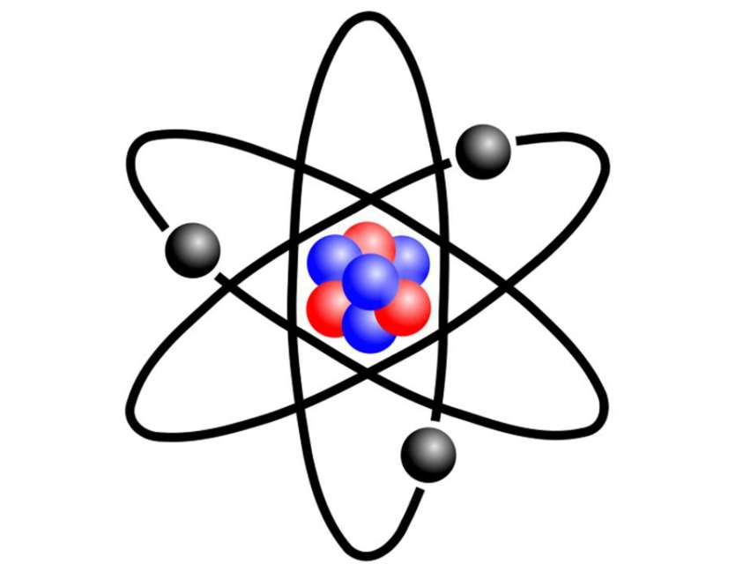
One of the most amazing machines

“The Sun is the only safe nuclear reactor, situated as it is
some ninety-three million miles away”
Stephanie Mills
Look at this photo. Can you guess what it is? 3.3

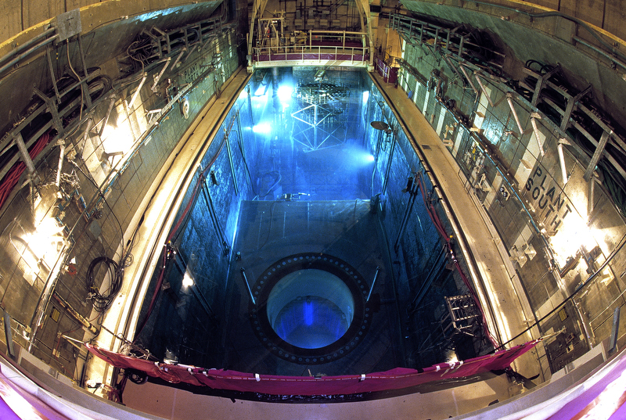

31 Answer these questions.
* Is nuclear energy clean?
* What element is used in nuclear reactors for energy?
* What is radiation?
* Is the fuel used in nuclear facilities efficient?

32 Work in pairs. Look at these sentences and decide if they are true (T) or false (F). Give reasons.
1 Radiation is man-made .T/F
2 Nuclear reactors can explode like bombs. T/F
3 Nuclear power plants produce little waste. T/F
4 Nuclear plants are efficient. T/F
5 It is not safe to live near and work in a nuclear power plant. T/F
6 Nuclear energy is rapidly expanding on a global scale. T/F

Did you know?
- Uranium is a source of today’s nuclear fuel. During the Middle Ages, craftspeople used it to colour glass yellow or certain shades of green.
- Radiation from the nuclear energy industry contributes to less than 1% of the radiation we receive from other sources.

33 Read the information and answer the questions.
1 How is nuclear energy released?
2 What is nuclear fusion?
3 What is nuclear fission?
4 What are the advantages of having nuclear power plants?

NUCLEAR ENERGY

Energy cannot be created nor be destroyed but it can be converted from one form to another.
Nearly all the mass of atom is concentrated in a tiny nucleus in the centre. The nucleus is composed principally of two sorts of particles: the proton which carries the positive charge
and the neutron which is electrically neutral and has a mass slightly bigger than that of proton.
Nuclear energy is the energy released from the nucleus of an atom. There are two ways for an atom to release nuclear energy. These are nuclear fission and nuclear fusion.
Nuclear fusion is energy released when two atoms join together to form a bigger atom.
Nuclear fission is energy released when an atom breaks and forms two smaller atoms.
The Sun is a great example of how nuclear fusion works and produces energy. The Sun produces an enormous amount of energy from its nuclear reactions that change hydrogen into helium.
In the process the Sun loses over 4 million tons of mass – every second!
Fission is the chain reaction which needs uranium.
The nuclear energy is considered as the worthiest alternative source of energy after fossil fuels.
Power plants that burn fossil fuels, such as coal and natural gas, produce huge quantities of carbon dioxide, a gas that contributes significantly to global warming. By contrast, nuclear power plants make heat without burning anything. The radioactive materials produce no carbon dioxide, making nuclear power plants serious alternatives for generating electricity.
Some sources of renewable energy, such as solar panels and wind turbines, also produce electricity without making carbon dioxide, but their power changes depending on the weather and time of day. Nuclear power plants generate the same power around the clock, every day, regardless of outside conditions.
Besides, nuclear power plants run for long periods on a relatively small amount of fuel.

34 Work in pairs. Discuss advantages and disadvantages of nuclear power energy generation.
Student A: you think that generation of electricity through nuclear energy is the only alternative.
Prompts: the lowest impact on the environment/ zero carbon emissions/efficient fuel/
one of the most affordable forms of energy/ reduces the amount of energy
generated from fossil fuels/ less fuel offers more energy/ nuclear power plants
generate electricity for almost 90 % of annual time regardless of outside
conditions.
Student B: you think that nuclear energy facilities are dangerous.
Prompts: enrichment of uranium generates harmful fossil fuel by-products/ nuclear plant
disasters/ Uranium is a non-renewable fuel/ the problem of radioactive waste is
still an unsolved one /the waste is extremely dangerous/ the time frame for
building a new nuclear power plant is of 10 – 20 years.

Use these expressions to express your opinion:
giving opinions agreeing partially agreeing disagreeing

I think/feel/believe that… That’s right I agree to some extent, but... I (totally) disagree
It seems to me that… I agree with you I see your point, but… I don’t agree
The way I see it… I suppose so Fair enough but… I’m not so sure

35 Watch the video “Nuclear Energy Explained – Risk or Opportunity”.
Answer these questions.

1 What are the main concerns surrounding nuclear energy?
2 What are the two main options for the treatment of nuclear waste?
3 Which method is more expensive?
4 There have been three major nuclear plant disasters. Do you remember them?
Complete the gaps.
_________________ 1979 ______________ 1986 _____________2011

36 Match words 1-8 to definitions a)-h).

1 nuclear a) very great
2 safe b) an act of using something to find out whether it is working correctly
3 disappear c) to make somebody or yourself believe that something is true
4 heat n d) to become impossible to see
5 tremendous e) using, producing or resulting from nuclear energy
6 explode f) the quality of being hot
7 test n g) protected from any danger or harm
8 convince h) to burst or make something burst loudly and violently, causing damage

37 Complete the sentences with the words from Exercise 37 in the correct form.

1The children are quite ______ here.
2 Our country side ________at an alarming rate.
3 He could feel the _______ of the sun on his back.
4 The ______energy is considered as the worthiest alternative source of energy after fossil fuels.
5 We tried to ________my grandfather to live with us.
6 A bomb __________ nearby.
7 Thunderstorms release _________amounts of energy.
8 The first nuclear _______ was conducted by The United States Army.

38 Read the quiz compiled by National Geographic below.
Work in pairs and take turns. Ask and answer the quiz questions.

1 Which of these scientific pioneers is credited with establishing the first commercial electric power plant?
- Benjamin Franklin
- Michael Faraday
- Thomas Edison
- Nikola Tesla

2 Why was an elephant electrocuted in New York in the early days of electric service?
- By accident, when Edison’s power plant at Luna Park Zoo malfunctioned.
- On purpose, in an effort by Edison to demonstrate the danger of high –voltage electricity.
- In an experiment by Edison to demonstrate the danger of high-voltage transmission.
- Edison defended himself against a rampage while stringing transmission wire at Luna Park Zoo.

3 Why isn’t electricity considered a primary energy source?
- It is not as powerful as other energy sources.
- It is not the first energy source discovered.
- It is not the most common energy source.
- It is produced by another energy source.
4 Coal, hydroelectric, wind, nuclear, and solar thermal power plants all have this equipment in common.
- Photovoltaic cells
- Boilers
- Turbines
- Flues
5 How does flipping a switch turn a light on?
- It steps up the voltage.
- It generates an electromagnetic field.
- It opens the circuit.
- It closes the circuit.
6 What units do electric companies generally use to measure how much power you use?
- Amperes
- Kilowatt-hours
- Kilowatts
- Volts
7 How long would you have to keep a ten-watt compact fluorescent light bulb turned on to consume one kilowatt-hour of electricity?
- 1 hour
- 10 hours
- 100 hours
- 1000 hours
8 What devices on the electric grid allow the high-voltage electricity that travels long distances on power lines to be transmitted to homes and businesses at the lower voltages needed for appliances?
- Transformers
- Circuits
- Turbogenerators
- Synchrophasor
9 Which of the following can cause disruptions to electricity service?
- Sea salt
- Squirrels
- Sunspots
- All of the above
10 How much of the world’s population has no access to electricity?
- 5 %
- 10%
- 20%
- 30%

39 Watch the video “Foreign Plural Nouns”. Then look at the words nucleus and phenomenon.
Are they in their singular or plural form?
A number of foreign (particularly Latin and Greek) nouns have retained their original plural endings. Practise reading these nouns. Mind the spelling.

Singular Plural
- is | ɪs | - es | iːz |
basis bases
crisis crises
analysis analyses

-on | ən | - a | ə |
phenomenon phenomena
criterion criteria

-us | əs | - I | aɪ |
nucleus nuclei
radius radii
stimulus stimuli

- a | ə | - ae | iː |
formula formulae (or regular – formulas)
antenna antennae (or regular – antennas)
persona *personae (or regular - personas)
- um | əm | - a | ə |
datum data
medium media

*Although originally a plural (the rarely used singular is datum and used with a plural verb, data is now often used as an uncountable noun with a singular verb).
* Mind false association. Persona – the aspects of a person’s character that they show to other people, especially when their real character is different.

40 Choose the correct alternative.

1 Many people have tried to analyse emotion, and I have read many such analyses / analysis
but none have ever really satisfied me.
2 There seemed to be varying criteria / criterion for the treatment of passengers by the immigration authorities, according to the class in which they travelled.
3 They had data / datum on health, education and economic development.
4 Paparazzi / paparazzo is a photographer who follows famous people around in order to get interesting photographs of them to sell to a newspaper.
5 We discussed the ever-growing popularity of talk radio and wondered how to explain this
phenomena / phenomenon.
6 The article will form the basis / bases for our discussion.
7 The axes /axis of a circle is its diameter.
8 They deliver to within a 5-mile radii / radius of the store.
9 His public persona / personae is quite different from the private family man described in the book.

41 There is one extra word in each of these sentences.
Correct each sentence by crossing it out.

1 Have they are come to see the new building?
2 The deadline has passed but they haven’t already finished the work yet.
3 I don’t think anyone has come it up with that idea before.
4 Have you got a one moment?
5 I’ve just now bought a new digital video recorder.
6 Researchers have been found that anyone of normal intelligence can be creative in the right
environment.
7 Have you ever written an email in the English?
8 He’s had had a mobile phone since last year.

42 Put the words in the correct order to make questions,

1 been/ What/ her/difficult/most/so far/ challenges/have?
2 university/she/ Which/ did/go/to?
3 France/Did/year/last/she/to/go?
4 Have/off/phone/turned/your/you/mobile/?
5 managed/to/homework/Have/your/finish/you/?
6 long/you/here/Have/been?
7 good/you/a/flight/Did/have/?
8 London/Have/ever/to/ been/you/?

43 Complete the conversations with the present perfect or
the past simple form of the verbs in brackets.

1 - Hey, Jim! (Not see) you for ages! You (not change) a bit!
- Yes, it’s been a long time since we (meet) last. And you (not get) older at all either.

2 – Hello, Ann! Mind if I join you?
- Not at all. Please take a seat.
- What’s new?
- I (pass) my driving test today.
- Congratulations!

Write a short dialogue using the present perfect and the past simple.

44 Put these words in the correct column.

criterion criteria theses thesis diagnoses diagnosis crisis crises bases basis
phenomenon phenomena radius radii paparazzo paparazzi
medium media nucleus nuclei

Singular Plural Singular Plural
_______ _______ _______ ________
_______ _______ _______ ________
_______ _______ _______ ________
_______ _______ _______ ________
_______ _______ _______ _________

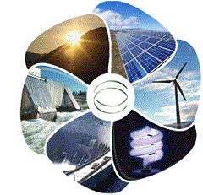

Powering the future

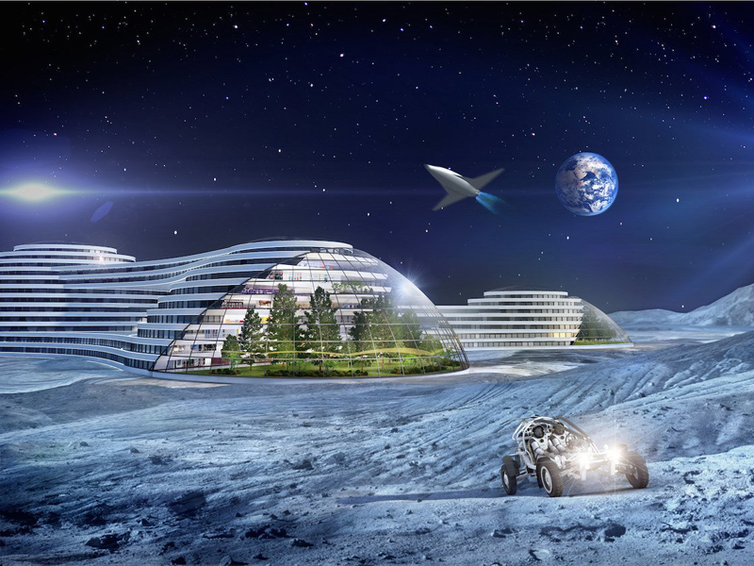
3.4
Look at this fascinating picture. Would you like to have the opportunity to drive that futuristic car?

45A Work in pairs and discuss the questions.

What will the world be like in 100 years?
What will have happened by then?
What will the cars of 2050 look like?
What will power them?

B Work in groups. Brainstorm several ideas for unusual energy sources.
Search the Internet if necessary.
Compare your ideas and choose the most promising ones. Give reasons.

46 Match words 1-8 with meanings a)-h).

1 commute a) make things to be sold, especially in large quantities
2 produce b) use
3 enormous c) join one thing to another
4 spotlight d) a reaction to something that has been done or said
5 utilize e) a quality of something that makes it better or more useful
6 response f) attention from newspapers, television and the public
7 attach g) large, huge
8 advantage h) travel regularly by bus, train, car, etc. between your place of work
and your home

47A Read the information. Did you mention these ideas in your previous discussion?
Think of headings for paragraphs 1-3. Discuss all these ideas in class.

UNBELIEVABLE NEW WAYS OF GENERATING ELECTRICITY

The Earth is in trouble, and it is definitely our fault. It seems clear at this point that traditional
methods of generating electricity are unsustainable, and we must find new energy sources that
do not produce as much carbon as natural gas and nuclear power.
The recognized need for alternative power sources is not new. We have seen massive solar arrays
displayed in vast deserts, enormous wind farms, wave energy farms, converting the power of our
oceans, and a host of biomass solutions arrive and disappear.
However, these forms of alternative energy are not the only game in town: there are a number of
weirder ways of generating power that scientists are investigating.
A great number of pilot and demonstration projects exist throughout the world, but only a handful
of technologies are close to commercialization. What do you think of these ones?
1 ______________________________
A number of major cities have begun harvesting the heat trapped in their vast metro systems.
Millions of commuters (not to mention the trains themselves) sealed in the insulated environment
of the metro can lead to enormous temperature differential. The heat produced can be converted
into power and heat for local homes, apartments and businesses.
Five hundred homes in the London borough of Islington, offices parallel to the Stockholm metro
and a Parisian *residential block are all harvesting human heat, with more buildings set to benefit
in the near future.
2 _______________________________
More people power, please! The kinetic energy generated by our everyday tasks is under the
spotlight as underground stations, nightclubs and gyms begin to utilize piezoelectric harvesting
technologies. Piezoelectricity is generated in certain crystals in response to compression force.
If you have a surface that’s moving for any reason, you can attach piezoelectric crystals to it,
and get small amounts of energy out. The accumulated electrical energy can be used to power
services within the same building or routed to a new location.
3 ________________________________
What could be more exciting or futuristic than a massive *solar array, floating on a platform
above the planet, beaming wireless electricity towards the Earth’s surface. There are a lot of
advantages in this option: no need to take up valuable real estate on Earth, and no energy
*fluctuations caused by weather. That said, there is a long way to go with this form of alternative
power. Wireless electricity transmission, long-term radiation shielding, meteorite protection and
the cost of putting the equipment into orbit are just some of the *stumbling blocks.

* residential block - жилой квартал
* solar array - панель солнечных батарей
* fluctuations – колебания
* stumbling block - камень преткновения
Roundup
Some of the alternative sources are bizarre, but some may have practical applications. Others are
already around us, providing us with alternative energy in our day-to-day. This sort of energy
research is critical, if we wish to continue to sustain our growing civilization without damaging the
planet.

B Write several sentences about your ideas for alternative power generation.
Work with other students. Discuss your ideas.

48 Complete the sentences with the words below in the correct form.

produce utilize enormous attach advantage commute spotlight response

1 The issue will come under the __________ when parliament reassembles.
2 I knocked at the door but there was no ___________.
3 The library’s great collection allowed me to __________ many rare sources.
4 The problems facing the President are ______________.
5 A small car has the added _________ of being cheaper to run.
6 I __________ a copy of my notes for your information.
7 She __________ from Oxford to London every day.
8 Dairy goods and beef __________locally.
49 Watch the video “The future perfect- BBC English Class”.
Then use the sentences below to complete the rules.

1 You will have got my cable and I’ll have received your answer long before this letter reaches you.
2 Will she have finished her work by Wednesday?
3 Simon will not have arrived before 8 p.m.
4 The work will have been finished by your return.
Future Perfect
FORM
Affirmative sentences
Use will +have +past participle
_______________________________
Negative sentences
Use will not/won’t + have + past participle
________________________________
Questions
Change the word order
________________________________
Passive forms
Use will + have + been + past participle
________________________________

50 Are these statements true (T) or false (F)?

1 The future perfect is the perfect tense for setting goals with deadlines. T/F
2 The future perfect describes a situation that is finished in the future. T/F
3 Perfect tenses are used to refer to completed or finished events. T/F
4 To talk about something that you’ll finish before a specific time
in the future use the future simple. T/F

51 Use the future perfect form of the verbs in brackets.

1 By the time I get home, Zoe (cook) dinner for both of us.
2 I hope that I (finish) my work before the weekend.
3 When you get this message, I (leave) for New York.
4 The robbers (take) all the money by the time anyone arrives.
5 We (return) home by five o’clock.
6 By the end of the month I (not complete) this project.
7 Nine o’clock is too late to arrive. The concert (start) by then.

52 Complete the sentences with the future perfect, future simple or future continuous form
of the verbs in brackets.

1 The sun (set) by the time we get home.
2 You (forget) me by then.
3 I don’t know what she (say) when sees it.
4 I hope you (have) a good sleep by that time.
5 Bye-bye…I (look) in again later on.
6 You’d better ring me back in half an hour. By then I (find) the letter.
7 At that time she (have) her early cup of coffee.
8 If we don’t get there before seven o’clock they (have) dinner.

53 Correct the mistakes in these sentences.

1 I’ll ring you up when I’ll have done my lessons.
2 We’ll talk about it when we’ll have had a cup of tea.
3 If you come back in about twenty minutes Alec and I will had had our talk.
4 When we get back, he will have a bath and we’ll find him asleep in his bed.
5 He says he will have finish the house by the end of the month.
6 He will has done his lessons by five o’clock.
7 Interfaces will have became easier to use by then.
8 Next week you will have this car for twenty five years!

54 Complete the sentences using the future perfect active or passive.
Use an affirmative sentence if you are sure and a negative one if you doubt it.

By 2020…
By 2020 engineers will have designed computer-guided cars.
1 By 2020 computer power / increase / ten / times
2 By 2020 money / replace / e-cash
3 By 2020 keyboards / disappear/
4 By 2020 machine intelligence /surpass / human intelligence
5 By 2020 flat screen LCD monitors / replace / all others
6 By 2020 the Internet replace/ by a better system
7 By 2020 shops/replace/ online shopping
8 By 2020 smoking/ban/ completely/ all public areas
55 A English speakers use ‘by the time’ to express a future event
that will happen after another future event.
Work in pairs.
Student A: offer a future event using ‘by the time’ and the simple present.
Student B: express a second event in the future perfect that will happen before the other event.
Then reverse roles.
Student A: By the time I graduate from BMSTU…
Student B: I will have become fluent in English.
B Create your own “Five Year Plan”. Share with the class what you will have done before
those five years are complete, using the future perfect.

56 Work in pairs. Complete the sentences with the numbers below.

10 million 25% 0,013% 4200 2500 10 billion 200 000

1 One terawatt can power ______ bulbs at the same time.
2 The US consumes _______ of the world’s energy.
3 Google alone consumes ________ of the world’s energy.
It is enough to continuously power ________ homes.
4 Food also contains energy which is measured in calories or joules.
1 calorie = ________ joules
5 If we take a standard daily diet for a male of around _______calories we find
our bodies need around ________joules each day.

57 Watch the video “Amazing Energy Facts to Blow Your Mind” and check your answers.
Then answer the questions.

1 What protects our bodies from an electric shock?
2 How much electricity does it take to actually kill a human?
3 Could you explain why a bird doesn’t get electrocuted sitting on a power line?
That’s because…
Prompts: both feet/ one power line/ touch another power line/ create flowing through the body/

TELLING FUNNY STORIES AND JOKES

58 Complete the information with the words fun and funny.

Don’t use____ and ______ in the same way.
Use _____ to talk about situations or activities that you enjoy.
The party was great _____.
______ is used to describe someone or something that makes you laugh.
The joke was really________.

59 Work in small groups. Discuss the questions below.

1 What is a joke?
2 Why do we tell jokes?
3 What are the golden rules for telling a joke properly?
4 What’s the normal way to respond to a joke?

60 Conduct a survey in your class. Ask and answer the questions.
Tell the rest of the class what you found out in your discussion.

1 What type of jokes do you prefer?
Surreal / jokes involving word plays / involving someone else looking stupid / any type of joke
2 Which animal or bird do people find the funniest?
Monkey /cat / duck / parrot / pig
3 When is the best time of day to tell a joke?
In the morning / in the evening / in the afternoon
4 When is the best time of the month to tell a joke?
At the beginning / in the middle / at the end of the month
5 Do people from different countries laugh at the same jokes?

61 Read the information and compare it with your answers.

GLOBAL HUMOUR

The year-long online search for the world’s funniest joke is over. The LaughLab experiment was
run by Richard Wiseman at the University of Hertfordshire, UK. The data showed clear national
differences in humour.
People from the UK, Ireland, Australia and New Zealand liked jokes involving a play on words,
Americans and Canadians preferred jokes where someone else looked stupid.
Many European countries liked jokes that were a bit surreal. Germans didn’t express a
strong preference for any type of joke. Wiseman’s team travelled widely to examine global
humour. They found that verbal jokes are common around the world except in one country, Japan.
The results suggest that people from different parts of the world have fundamentally different
senses of humour. “ Humour is vital to communication and the more we understand about how
people’s culture and background affect their sense of humour, the more we will communicate
effectively,” says Wiseman.
The team’s analysis has also revealed the world’s ‘funniest animal’- the duck. So, if you are going
to tell a joke, involving an animal, make it a duck.
The other interesting thing about humour is that it’s all about timing… It seems people find the
jokes funniest at six in the evening…People also found jokes funnier at different times during the
month. They were funniest on the fifteenth and less funny towards the end or start of the month.
So, if you want to make people laugh, tell a joke on the fifteenth of the month, at six in the evening!

62 Think of a funny joke and tell it to the rest of your group.
REVIEW 1-4
63 Match the beginnings and endings of these sentences to make quotes.

1 Nor must we forget that in science
2 The important thing in science is not so much
to obtain new facts,
3 The most wonderful discovery made by scientists
4 The scientist is not a person who gives the right answers,
5 Facts are the air of the scientists.
6 When a distinguished but elderly scientist states that something is possible,
he is almost certainly right.

a) he is one who asks the right questions.
b) is science itself.
c) Without them you can never fly.
d) When he states that something is impossible, he is very probably wrong.
e) there are no final truths.
f) as to discover new ways of thinking about them.

64 Look at the prompts and write the correct definition of electricity.
electrons / protons / called / of / properly / electrical energy/ behaviour /
caused by / a form / energy / of /and.

Electricity is…

65 Put the verbs in brackets in the correct perfect tense to get a famous saying.

Education is what survives when what (learn) (forget).

IRREGULAR VERBS

Verb Past simple Past participle Verb Past simple Past participle
be | was/were | been | hold | held | held
beat | beat | beaten | hurt | hurt | hurt
become | became | become | keep | kept | kept
begin | began | begun | know | knew | known
bend | bent | bent | lay | laid | laid
bet | bet | bet | lead | led | led
bite | bit | bitten | learn | learned/learnt | learned/learnt
bleed | bled | bled | leave | left | left
blow | blew | blown | lend | lent | lent
break | broke | broken | let | let | let
bring | brought | brought | lie | lay | lain
broadcast | broadcast | broadcast | light | lit | lit
build | built | built | lose | lost | lost
burn | burned/burnt | burned/burnt | make | made | made
burst | burst | burst | mean | meant | meant
buy | bought | bought | meet | met | met
catch | caught | caught | pay | paid | paid
choose | chose | chosen | put | put | put
come | came | come | read | read/red/ | read/red/
cost | cost | cost | ride | rode | ridden
cut | cut | cut | ring | rang | rung
deal | dealt | dealt | rise | rose | risen
dig | dug | dug | run | ran | run
do | did | done | say | said | said
draw | drew | drawn | see | saw | seen
dream | dreamed/t | dreamed/t | sell | sold | sold
drink | drank | drunk | send | sent | sent
drive | drove | driven | set | set | set
eat | ate | eaten | shake | shook | shaken
fall | fell | fallen | shine | shone | shone
feel | felt | felt | show | showed | shown
feed | fed | fed | sing | sang | sung
fight | fought | fought | sit | sat | sat
find | found | found | sleep | slept | slept
fly | flew | flown | speak | spoke | spoken
forbid | forbade | forbidden | spell | spelt | spelt
forget | forgot | forgotten | spend | spent | spent
forgive | forgave | forgiven | swim | swam | swum
freeze | froze | frozen | take | took | taken
get | got | got | teach | taught | taught
give | gave | given | tell | told | told
go | went | gone | think | thought | thought
grow | grew | grown | throw | threw | thrown
hang | hung | hung | understand | understood | understood
have | had | had | wake | woke | woken
hear | heard | heard | wear | wore | worn
hide | hid | hidden | win | won | won
hit | hit | hit | write | wrote | written

Sources

Module 3

Definitions:
Robert L. Boylestad, Introductory Circuit Analysis
Pearson Education, 2003
Cambridge Academic Content Dictionary
Cambridge University Press, 2009
Oxford Advanced Learner’s Dictionary
Oxford University Press, 2004
Text: Bio-inspired technologies
https://cosmosmagazine.com/technology/10-technologies-inspired-nature
Text: History of Electricity
http://www.code-electrical.com/historyofelectricity.html
http://www.scienceandinventions.com/who-discovered-electricity/
Text: Nikola Tesla
http://www.biography.com/people/nikola-tesla-9504443
Text: Nuclear Energy
http://www.conserve-energy-future.com/advantages_nuclearenergy.php
Quiz:
http://environment.nationalgeographic.com/environment/energy/great-energy- challenge/electricity-quiz/
Text: Unbelievable New Ways of Generating Electricity
http://www.makeuseof.com/tag/8-unbelievable-new-ways-generating-electricity/
Text: Global Humour
https://www.newscientist.com/article/dn2876-worlds-funniest-joke-revealed/
Video sources:
The Discovery of Electricity
https://www.youtube.com/watch?v=OesCNKaqc8o
Did Nikola Tesla Invent Free Energy?
https://www.youtube.com/watch?v=1NyJUoCSAfg
Nuclear Energy Explained – Risk or Opportunity
https://www.youtube.com/watch?v=d7LO8lL4Ai4
Amazing Energy Facts to Blow Your Mind
https://www.youtube.com/watch?v=TnNixMosUIo
Grammar:
Present perfect
https://www.youtube.com/watch?v=ODt_xD5OhK8
Past perfect
https://www.youtube.com/watch?v=iIL8LDt1gZU
Foreign Plural Nouns
https://www.youtube.com/watch?v=L6pH8O3B4ak
Future perfect
https://www.youtube.com/watch?v=UNF8Vnrpxno
Quotes:
https://wwwbrainyquote.co/

